**Topics In Software Engineering**

**Assignment 01**

**Group Name:**

**The incrEDIBLES**

**Group Members:**

**Rizwan Hameed (FA19-BSE-060)**

**Samia Amjad Butt (FA19-BSE-108)**

**Amasil Fazal (SP19-BSE-072)**

**Arfat Sarwar (FA18-BSE-102)**

**Section:**

**FA19-BSE-B**

**Submitted to**

**Ma’am Fatima Sabir**

**Date:**

**03-10-2022**

**Project used: Restaurant Management System**

**Question a)**

1- There is no use of any deprecated technology or diagram in this documentation.

The team has used a waterfall model but we think agile would have been better as it does not require deliverables for each phase.

2- Canteen Management System is not written in the document but it is used in the code. The Database System is also not mentioned in the documentation.

3- Work breakdown structure diagram and Activity Diagram is missing in the document.

These should be included in the documentation because these help you to know the steps of your work.

**Question b)**

**1-The serializable class Frame1 does not declare a static final serialVersionUID field of type long**

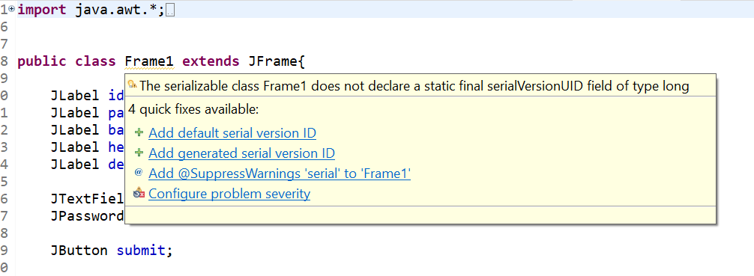

The issue can be resolved by adding default serial versions id.

**2-The value of the field DeleteFood.price is not used.**

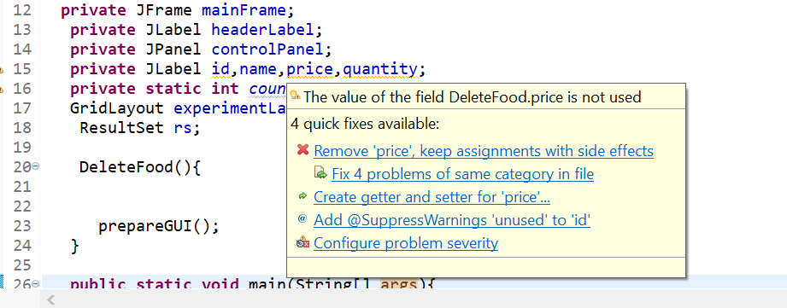

We can comment those declarations which are not being used within the code.

**Minimizing Technical Debt:**

It’s the result of prioritizing speedy delivery over perfect code.

It can be minimized by commenting long methods into shorter ones.

We can remove unused variables.

Refactoring is hard when complexity is high..

**Code Quality:**

# **1-The default unnamed package should not be used. According to the Java Language Specification.**

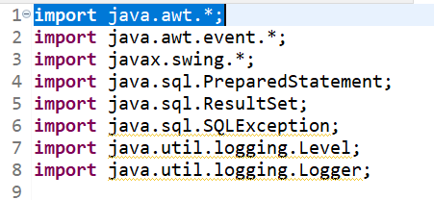

# Unnamed packages are provided by the Java platform principally for convenience when developing small or temporary applications or when just beginning development.

**2-"@Override" should be used on overriding and implementing methods**

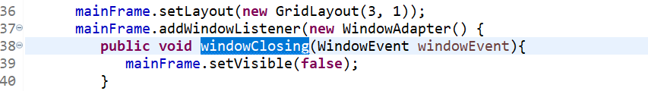

# Using the @Override annotation is useful for two reasons :

# It elicits a warning from the compiler if the annotated method doesn’t actually override anything, as in the case of a misspelling.

# It improves the readability of the source code by making it obvious that methods are overridden.

**3- PMD Rules**

**i)** Change is recommended.

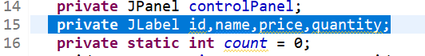

In java there should be one declaration per line of the same type.

**ii)**Change is required.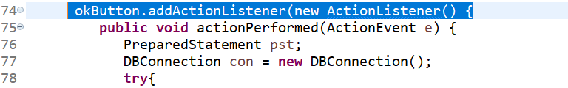

# Anonymous inner classes containing only one method should become lambdas.

With Java 8, most uses of anonymous inner classes should be replaced by lambdas to highly increase the readability of the source code.

**iii) Change is recommended**

Multiple markers at this line

- Type name 'foodCart' must match pattern '^[A-Z][a-zA-Z0-9]*$'.

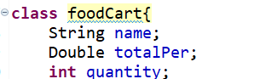

The issue can be resolved by renaming this class to match the regular expression.

**v) Abstract Syntax Tree:**

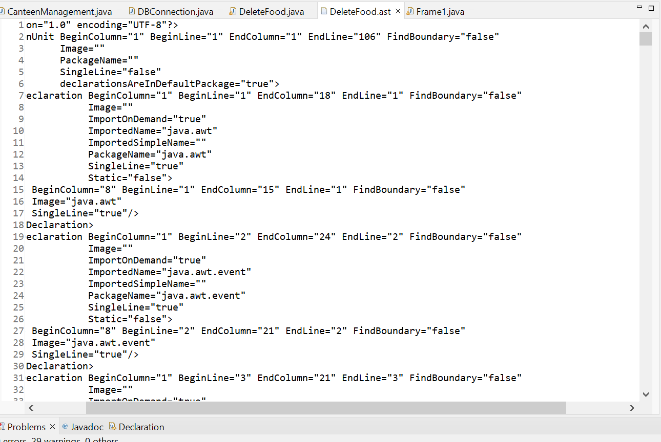

**Question c)**

We worked on the EnterFood.java file. After installing the Check Style in my eclipse. Here are some code convention issues that I am going to mention in the assignment.

**1-** **Unresolved Indentation (Checks that 'method def' child has incorrect indentation e.g; level 6, expected level should be 4.)**

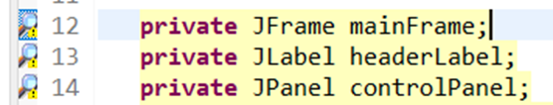

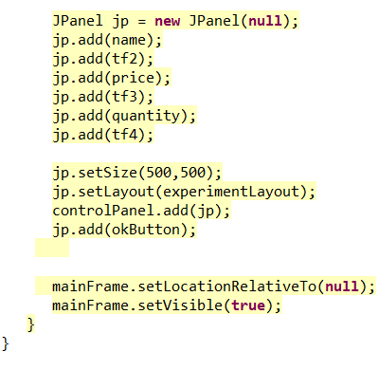

There are some spacing issues with the code that error can be resolved by reducing the space. The modifier has incorrect indentation.

**2-** **MultipleVariableDeclarations (Checks that each variable declaration is in its own statement and on its own line)**



This error will be resolved if we declare each variable separately in different lines.

**3-**  **LineLength (Checks for long lines)**



Check Style also looks for long lines in the code. Here I get the warning: the line contains 136 characters which are longer than 100 characters.

This warning can be removed by only writing 100 characters on one line.

**4-** **WhitespaceAround (Checks that a token is surrounded by whitespace)**

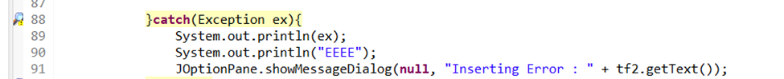

Here we get the recommendation that ‘catch’ is not preceded with whitespace.

This error can be resolved simply by adding space before ‘catch’.

# 